Program:

//SPDX-License-Identifier: MIT

pragma solidity ^0.8.0;

// Creating a Smart Contract

contract p1{

// Structure of student

struct student{

// State variables

int sid;

string name;

string department;

}

student []s1;

// Function to add student details

function addStudent(

int sid, string memory name,

string memory department

) public{

student memory s

=student(sid,

name,

department);

s1.push(s);

}

// Function to get details of student

function getStudent(

int sid

) public view returns(

string memory,

string memory){

uint i;

for(i=0;i<s1.length;i++)

{

student memory s

=s1[i];

// Looks for a matching student id

if(s.sid==sid)

{

return(s.name,

s.department);

}

}

// If provided student id is not present returns "Not Found"

return("Not Found",

"Not Found");

}

}

Steps:

1. Go to <https://remix.ethereum.org/>
2. In contracts folder, create a new file, name it, type the code and save it.
3. Compile and deploy.

Output Screenshots:

Deployed contract: 0xddaAd340b0f1Ef65169Ae5E41A8b10776a75482d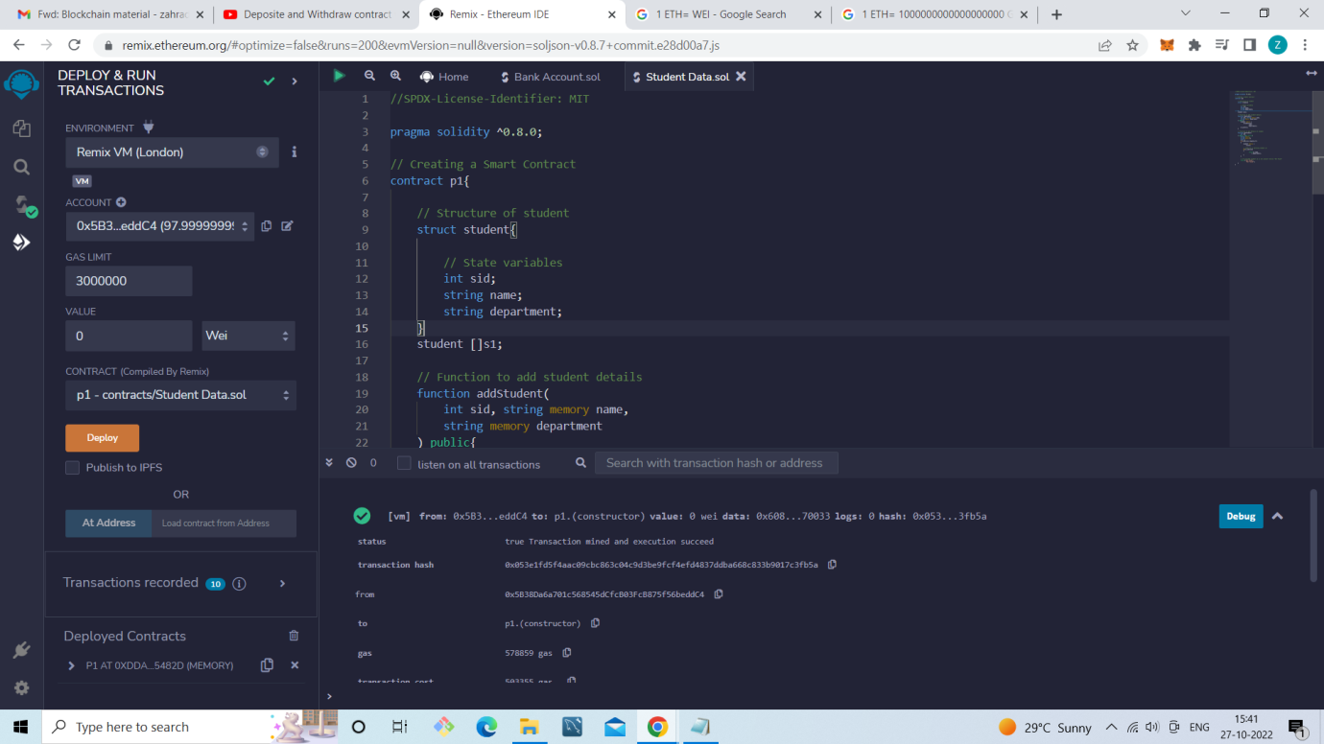

Enter Student Data:

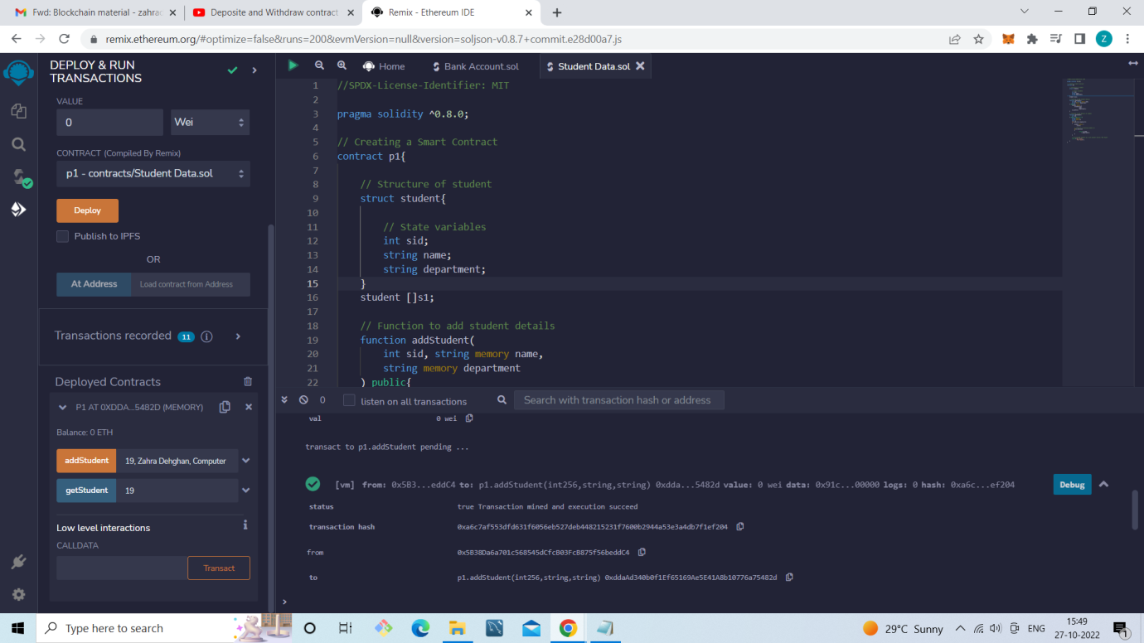

Get Student Data using ID :

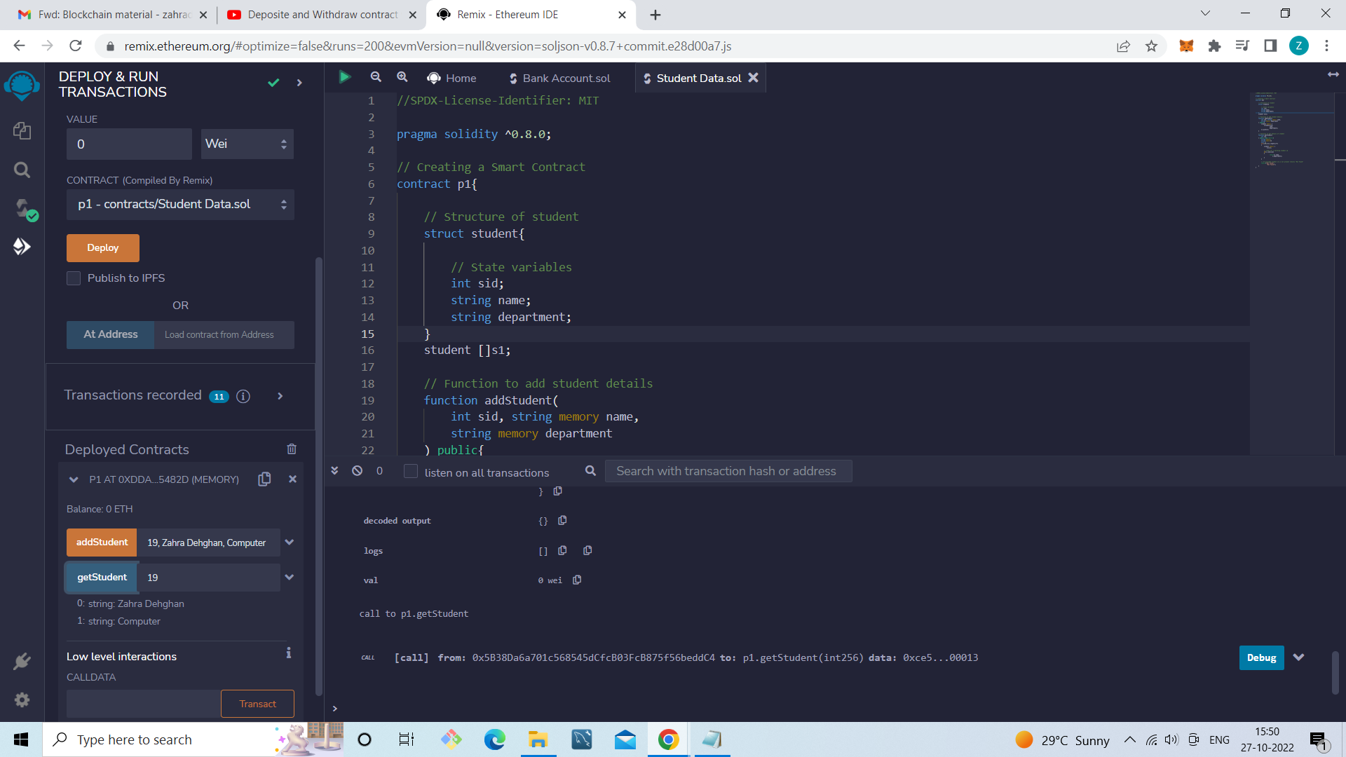

If provided student id is not present it returns "Not Found"

